

SCHOOL OF MECHANICAL & MANUFACTURING ENGINERRING

NUST

Department of Mechanical Engineering

CS-114 – Fundamentals of Programming

LAB MANUAL #02

**Course Instructor**: Dr Khawaja Fahd Iqbal

**Lab Instructor**: Muhammad Affan

**Student Name**: Muhammad Usman Abdullah

**Section**: B

**CMS ID**: 461513

**DATE**: 11-October-2023

ASSIGNMENT 2 (HOME TASK)

TASK 1:

#include <iostream>

using namespace std;

//C++ Program to take student's score as input and assign a grade

//using nested if-else and logical operators

int main(){

int score;

cout<<"Enter the student's score"<<endl;

cin>>score;

if (score>=90 && score<=100){

cout<<"The student got grade:A"<<endl;

}

else if(score>=75 && score<90){

cout<<"The student got grade:B"<<endl;

}

else if(score>=60 && score<75){

cout<<"The student got grade:C"<<endl;

}

else if(score>=45 && score<60){

cout<<"The student got grade:D"<<endl;

}

else{

cout<<"The student got grade:F"<<endl;

}

return 0;

}

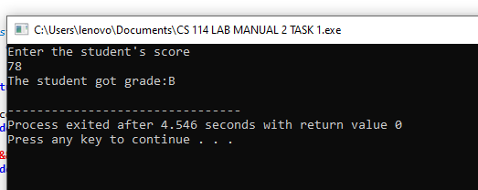

TASK 2:

#include <iostream>

using namespace std;

//To take input as integer and check if it is both even and divisible by 5

int main(){

int number;

cout<<"Enter an integer"<<endl;

cin>>number;

if (number%2==0 && number%5==0){

cout<<"The number is even and divisible by 5"<<endl;

}

else if(number/2){

cout<<"The number is even but not divisible by 5"<<endl;

}

else{

cout<<"The number is not even and not divisible by 5"<<endl;

}

return 0;

}

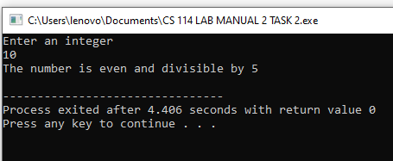

TASK 3:

#include <iostream>

using namespace std;

//To check if user-entered year is a leap year

int main(){

int year;

cout<<"Enter year"<<endl;

cin>>year;

if (year%4==0){ //Since a leap year comes every 4 years so it should be divisible by 4

cout<<"It is a leap year"<<endl;

}

else{

cout<<"It is not a leap year"<<endl;

}

return 0;

}

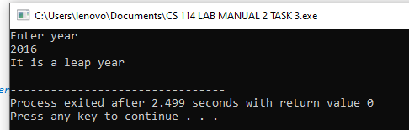

TASK 4:

#include <iostream>

using namespace std;

int main(){

float gpa;

float attendance;

cout<<"Enter the student's gpa"<<endl;

cin>>gpa;

cout<<"Enter the students attendance percentage"<<endl;

cin>>attendance;

if((gpa>=3.5) && (attendance>=80)){

cout<<"The student is eligible for scholarship"<<endl;

}

else{

cout<<"The student is not eligible for scholarship"<<endl;

}

return 0;

}

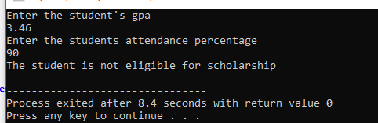

TASK 5:

#include <iostream>

using namespace std;

int main(){

char letter;

cout<<"Enter a letter"<<endl;

cin>>letter;

if (letter=='a'|| letter=='e'||letter=='i'||letter=='o'||letter=='u'){

cout<<"The letter is a vowel"<<endl;

}

else{

cout<<"The letter is a consonant"<<endl;

}

return 0;

}

